**Watch Store**

# Project Report

Submitted as Partial Fulfillment of

Master of Computer Application

Semester-VI

**Developed at**

**TechnoMark Solutions LLP.**

**Developed by**

**Ruchit Jivnani (202100721010017)**

**Soumy Oza (202100721010034)**

**Mahaveer Trivedi (202100721010066)**

**Under Guidance of**

Dr. Devarshi Metha, FCT

Mr. Karan Ekkawala, Technomark Solutions LLP.

Faculty of Computer Technology (GLSICT)

GLS University

Ahmedabad-380 006

|  |  |
| --- | --- |
| **Project Title:** | **Watch Store** |
| **Description:** | Discover the perfect timepiece for your wrist at our online watch store. Explore our curated collection of stylish and reliable watches, ranging from classic to modern designs. Shop now and elevate your style with our premium timekeeping options. |
| **Aim** | Our future aim is to become the go-to destination for watch enthusiasts, providing an unparalleled online shopping experience with a wide selection of high-quality timepieces, exceptional customer service, and a seamless browsing and purchasing process. Stay tuned for exciting updates and new additions to our ever-growing watch collection! |
| **Category** | E-Commerce Website |
| **Tools Used / Required:** | **Development Side:**   * **Software:** * **Operating System: Windows 11** * **Front End: C#, WordPress** * **Back End: MySQL** * **Framework: .NET 6** * **Architecture:** * **MVC** * **N-Tier Architecture** |
| **Developed At** | **Technomark Solutions LLP** |
| **Developed By:** | |  |  |  |  | | --- | --- | --- | --- | | **Enroll No.** | **Name** | **Institute** | **Contribution** | | **202100721010017** | Ruchit Jivnani | FCT | Backend | | **202100721010034** | Soumy Oza | FCT | Frontend | | **202100721010066** | Mahaveer Trivedi | FCT | Frontend | |
| **Guided By:** | |  |  | | --- | --- | | **Internal Guide** | **External Guide (at company)** | | **Name**: Dr. Devarshi Mehta  **Designation**: Professor | **Name**: Karan Ekkawala  **Designation**: Team Leader | |

# Certificate

# This is to certify that

# Ruchit Jivnani, 202100721010017

# Soumy Oza, 202100721010034

# Mahaveer Trivedi, 202100721010066

# 

# Students of MCA semester IV of

# Faculty of Computer Technology

GLS University

# have successfully completed the full-time project work entitled

***“Watch Store”***

# developed at

# “Technomark Solutions LLP”

# as a partial fulfillment of the study of

# Master of Computer Application

|  |  |  |
| --- | --- | --- |
| (Dr. Devarshi Mehta) | (Dr. Devarshi Mehta) | (Dr. Harshal Arolkar) |
| Internal Guide | Project Coordinator | Head, PG Programme |
|  |  |  |
|  | (Dr. Savita Gandhi)  Dean |  |

**Acknowledgment**

I express my heartfelt thanks to my project guide **Dr. Devarshi Mehta (Internal Guide)** for their continuous support and guidance throughout the project.

We would like to forward my thanking tribute to **Dr. Harshal Arolkar (Head, PG Programme)** and **Dr. Savita Gandhi (Dean)** and GLS University to whom pleasurable debit for his splendid support, inspiration and thought production.

We would like to thank my Tech Leader **Mr. Karan Ekkawala, Rajesh Mauliya, and Arun HK** for all kind of their continuous support and guidance throughout the project. I take this opportunity to express my sincere thanks and deep gratitude to all those people who extended their wholehearted co-operation and have helped me in completing this project successfully.

I am thankful to Technomark Solutions LLP for Training Associates for teaching and assisting me in making the training successful.

Last but not the least we would like to express our sincere gratitude towards all our teachers for their skillful teaching, precious suggestions and encouragements.



**Introduction of the Company**

TechnoMark helps businesses create a unique digital identity through premium services in website design and development, mobile app development and software development.

We serve businesses globally with our penchant for highly robust and scalable business solutions. Our commitment to quality has got us clients in USA, UK, Canada, Australia, India and Other Countries.

Technomark Solutions LLP is a team of exceptionally talented people set to revolutionize modern-day technology. We are your preferred partners for Software, Web, mobile app, and E-commerce Development Services. We breathe technology into your ideas.

Website Link: - <https://technomark.io/>

**Index Page**

|  |  |
| --- | --- |
| **Sr. No.** | **Main Topic** |
| **1.** | Abstract |
| **2.** | Team Details |
| **3.** | Project Timeline |
| **4.** | Need of System |
| **5.** | Hardware/Software Requirement |
| **6.** | Feasibility Study |
| **7.** | Software Requirement Specifications |
| **8.** | Data Dictionaries |
| **9.** | GUI Screenshots |
| **10.** | Learning and Work Experience |
| **11.** | Future Enhancements |
| **12.** | Appendix |

**Abstract**

Our website is designed to provide an effortless and enjoyable shopping experience for watch enthusiasts. The system starts with a user-friendly interface that allows customers to easily navigate through our curated collection of watches. Our website features detailed product descriptions, including specifications, materials, and design details, to help customers make informed decisions.

Consumers can browse our wide selection of timepieces, which features both traditional and contemporary styles from well-known watch manufacturers. Customers can check the timepieces' craftsmanship and attractiveness by viewing the high-quality photographs of them taken from various perspectives.

To ensure a secure transaction process, our website offers multiple payment options, including encrypted payment gateways that protect customers' personal and financial information. Customers can add selected watches to their cart, review their order, and proceed to checkout with confidence.

Our system also includes exceptional customer service, with prompt and helpful responses to customer inquiries, order tracking, and hassle-free returns and exchanges. We strive to provide a seamless and reliable online shopping experience to our customers, ensuring their satisfaction and trust in our website.

We intend to continually expand our watch collection in the future to provide even more options for our customers, including limited editions, exclusive collaborations, and new releases. We also intend to improve our website with innovative features and technologies in order to improve the browsing and purchasing experience for all watch enthusiasts who visit our website.

In summary, our website is intended to provide a comprehensive and seamless online shopping experience for watch enthusiasts, with a carefully curated collection of high-quality watches, exceptional customer service, and secure payment options.

**Team Details**

1. Ruchit Jivnani: -
   * **Enrollment number: -** 202100721010017
   * **Contribution: -** Maintaining the backend part of the system. Including Database Management.
2. Soumy Oza: -
   * **Enrollment number: -** 202100721010034
   * **Contribution: -** Maintaining the frontend part of the system. Including all Designing and user side management.
3. Mahaveer Trivedi: -
   * **Enrollment Number**: - 202100721010066
   * **Contribution:** - Maintaining the validations for Client and Server side.

**Project Timeline**

**Phase 1: - Project Initiation and Market Research (4 weeks)**

* Define project Scope, Objectives, and Team Roles.
* Gathering information on Watch brands.

**Phase 2: - Website Backend Designing and Development (2 weeks)**

* Creating database and Tables.
* Creating Backend functionalities, including product catalog, payment gateway integration.

**Phase 3: - Content Creation and Product research (3 weeks)**

* Developing compelling and engaging content for production descriptions, about us, and other relevant pages on the website.
* Curate and select watches to be included in the website's inventory

**Phase 4: - Website Frontend Designing and Development (3 weeks)**

* Creating a mockup, and design for the website.
* Creating a responsive UI for the website so that end-user can use it properly.

**Phase 5: - Finding out Bugs and adding some new code and functionality (5 weeks)**

* Conduct a testing and quality assurance to identify and fix any bugs or issues.

**Needs and Benefits of this System.**

* Customers can browse and purchase watches online at their convenient, without the need to visit at store physically. They can view product images, descriptions, and specifications, compare prices, and make secure online payments, offering a seamless and convenient shopping experience.
* The website can offer a diverse range of watches from various brands, styles, and price points, providing customers with a wide selection to choose from. It can also ensure product availability and real-time inventory management, reducing the risk of out-of-stock situations.
* The website can incorporate search and filtering functionalities, allowing customers to easily find and navigate through different watches based on their preferences, such as brand, type, price, and features, enhancing the overall user experience.
* The website can provide detailed product information, including images, descriptions, specifications, and customer reviews, helping customers make informed purchase decisions based on their requirements and preferences.
* The website can integrate secure payment gateways, ensuring that customer payment information is protected and transactions are processed securely, instilling trust and confidence among customers.
* The e-commerce website can open up opportunities for tapping into new customer segments, thereby potentially increasing sales and revenue.

**Hardware / Software Requirements at Development**

* **Hardware Requirements:**
  + **Device Name**: 01-CPU-A603
  + **Processor**: Intel(R) Core (TM) i5-8500 CPU @ 3.00GHz 3.00 GHz
  + **RAM**: 16.00 GB
  + **Edition**: Windows 11 Pro
* **Software Requirements:**
  + Visual Studio 2022
  + XAMPP control Panel (For MySQL)
  + Postman (For API integration)
  + Swagger (For API integration)

**Feasibility Study of the Developed System**

1. **Financial Feasibility: -** 
   * Evaluate the financial performance of the e-commerce watch website, including revenue generation, profitability, and cash flow.
   * Generating enough revenue and profits to cover all of its operating expenses, such as website upkeep, hosting fees, payment gateway fees, and personnel costs.
2. **Market Analysis: -** 
   * Conduct a market analysis to assess the current market demand for watches and customer preferences.
   * Identify any changes in the market dynamics, customer preferences, or competitive landscape that may impact the website's performance.
3. **Operational Feasibility: -**
   * Evaluate the organizational components of running the watch e-commerce website, like as order processing, inventory management, customer support, and fulfilment.
   * To ensure operational efficiencies, assess the availability of key resources such as personnel, technology, and logistics.
4. **Customer Feedback and Satisfaction: -**
   * Get feedback from users of the website regarding their satisfaction level, recommendations, and grievances.
   * According to customer feedback, evaluate any areas which might require improvement and take the necessary measures to fix them.

**Software Requirement Specifications**

1. **Activity Diagram (Login and Registration)**

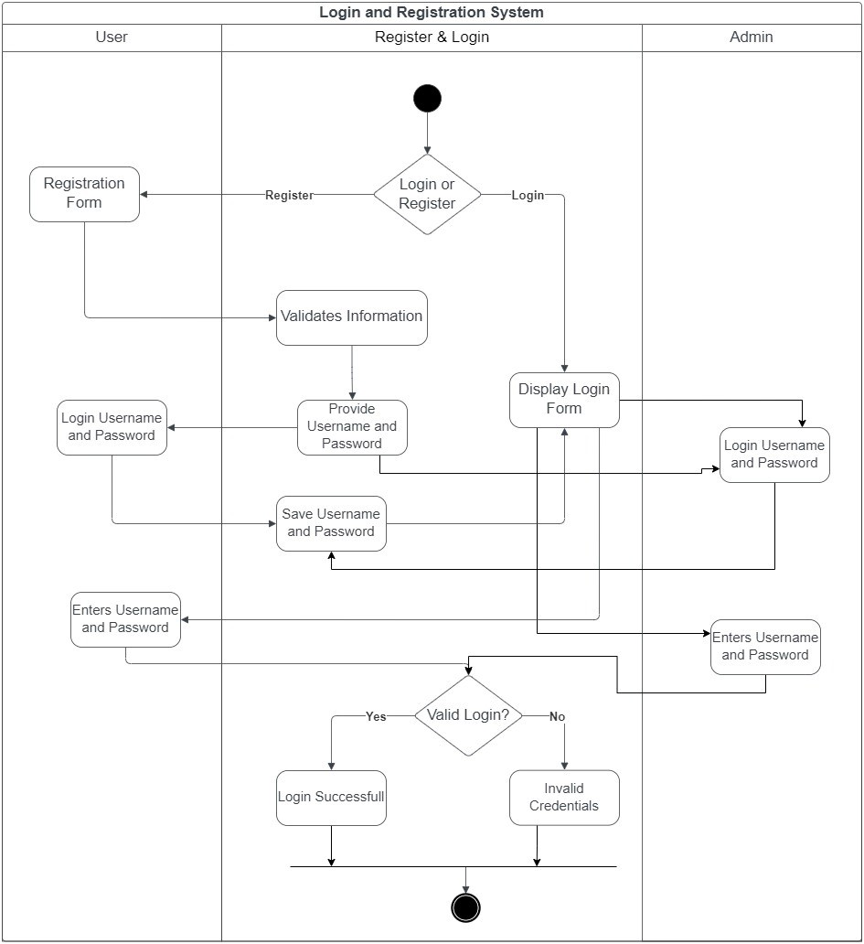

1. **Activity Diagram (Admin Side):**

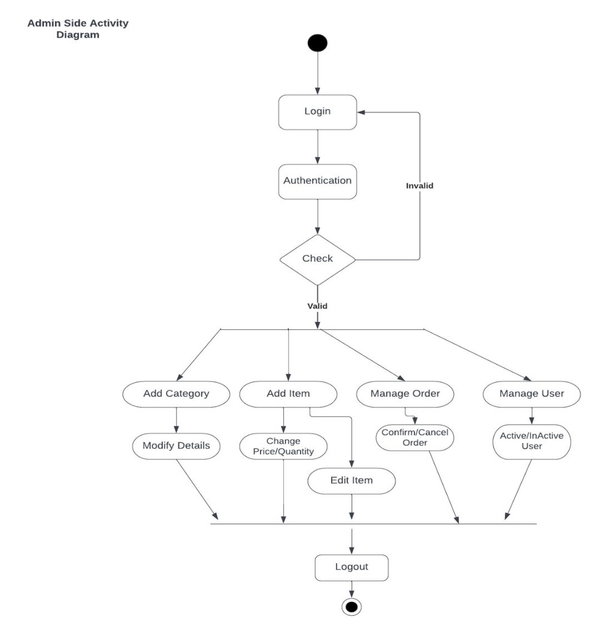

1. **Use Case Diagram (Of System): -**

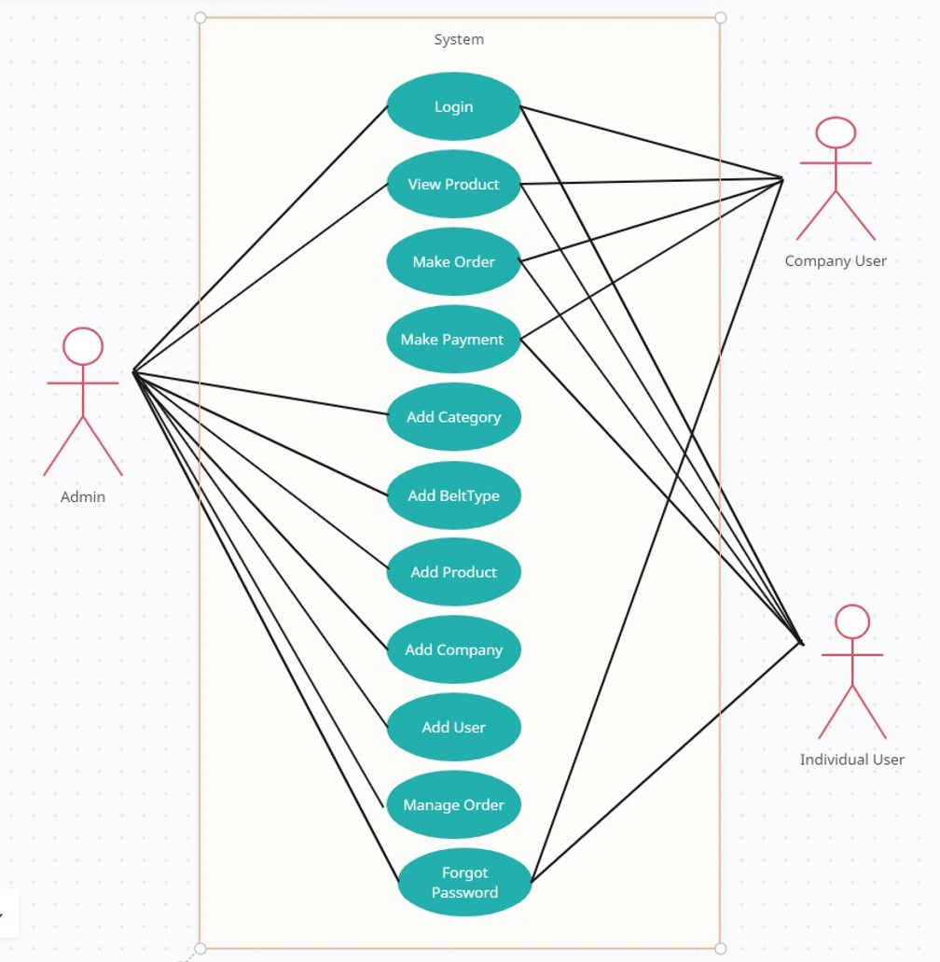

1. **Sequence Diagram (Login):**

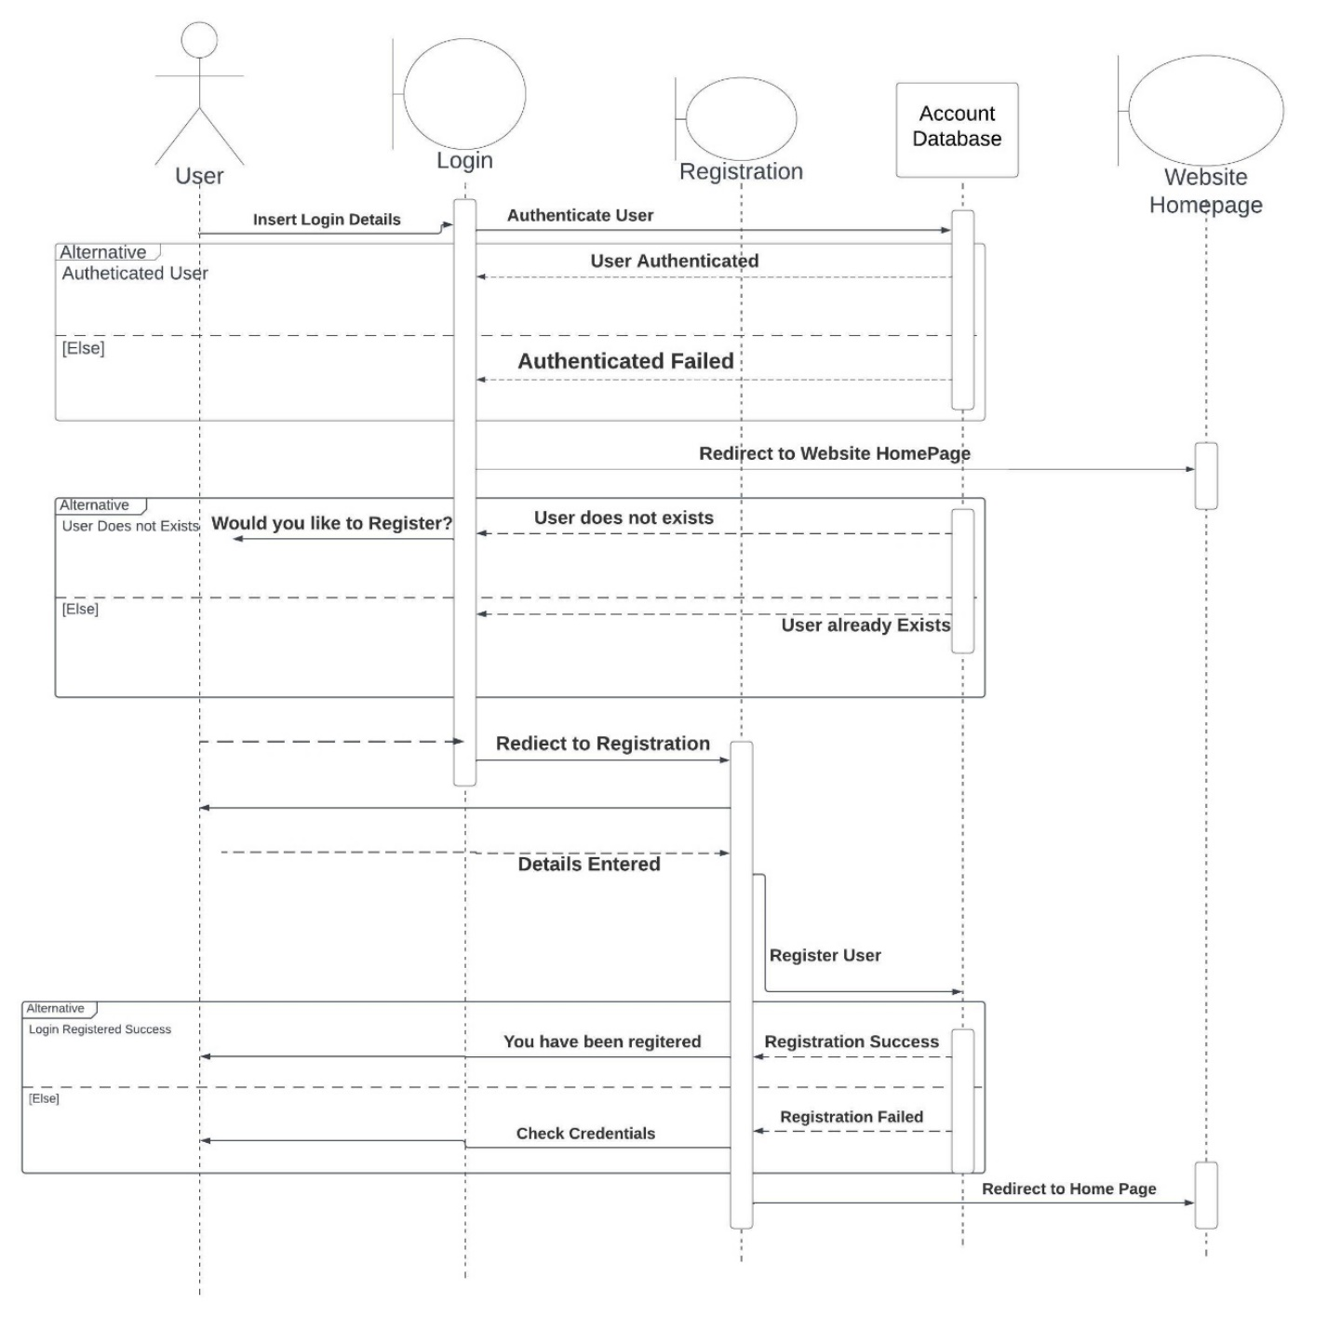

1. **Admin Side Sequence Diagram:**

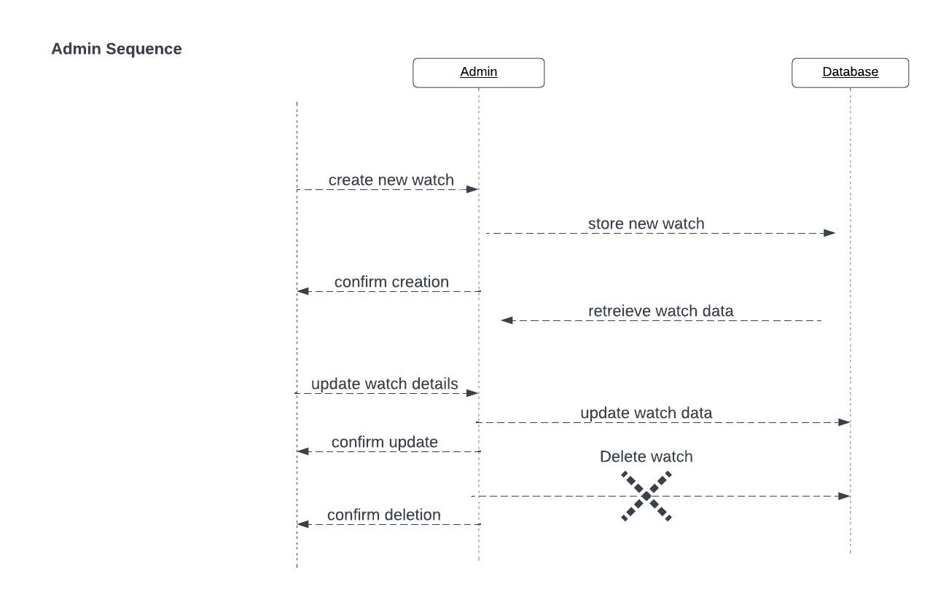

1. **Sequence Diagram for Manage Profile